

PLACEMENT EMPOWERMENT PROGRAM

Cloud Computing & DevOps center

Set up a local Github Repository: Initialize a Github repository locally and version control your static website.

Name: SHIYAM MARTEIN A S

Dept: IT

INTRODUCTION

To initialize a GitHub repository locally and version control a static website, you begin by setting up a GitHub repository on the platform and then clone it to your local machine. Next, you create your static website or ensure that the project files are in place. Using Git, you initialize a repository in your local directory and add the necessary files. After committing these files, you can push the changes to the GitHub repository, allowing for remote storage and version control. This process not only tracks changes over time but also facilitates collaboration, backup, and efficient management of updates to your static website.

**Step-by-step process**

**Step 1:** Create a folder named “web” in your deskstop.



Step 2: Open the “cmd prompt” and navigate to the folder that you created in your desktop.

“cd C:\Users\getpr\OneDrive\Desktop”

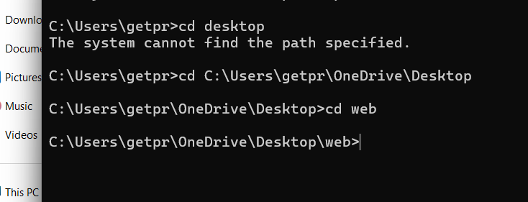

Step 3: Once you opened the folder, run the following Github cmds.

Cmd 1: git init

Cmd 2: git add .

🡪Git congigurations:

Cmd 3: git config –global user.name “pranav46-hakiman”

Cmd 4: git config –global user.email [get.pranavk23@outlook.com](mailto:get.pranavk23@outlook.com)

Cmd 5: git commit -m “my first commit of my website”

Cmd 6: git remote add origin <https://github.com/pranav46-hakiman/myweb.git>

Cmd 7: git push origin main – used for login in and uploading the file.

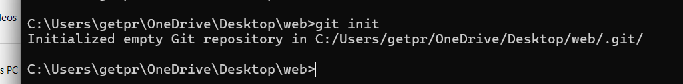

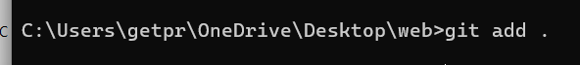



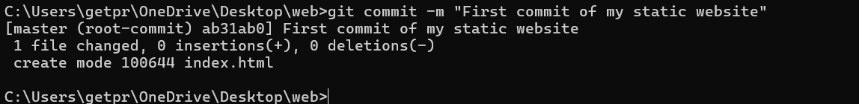

Step 4: Go to your Github account and check whether the file has been uploaded or not.

